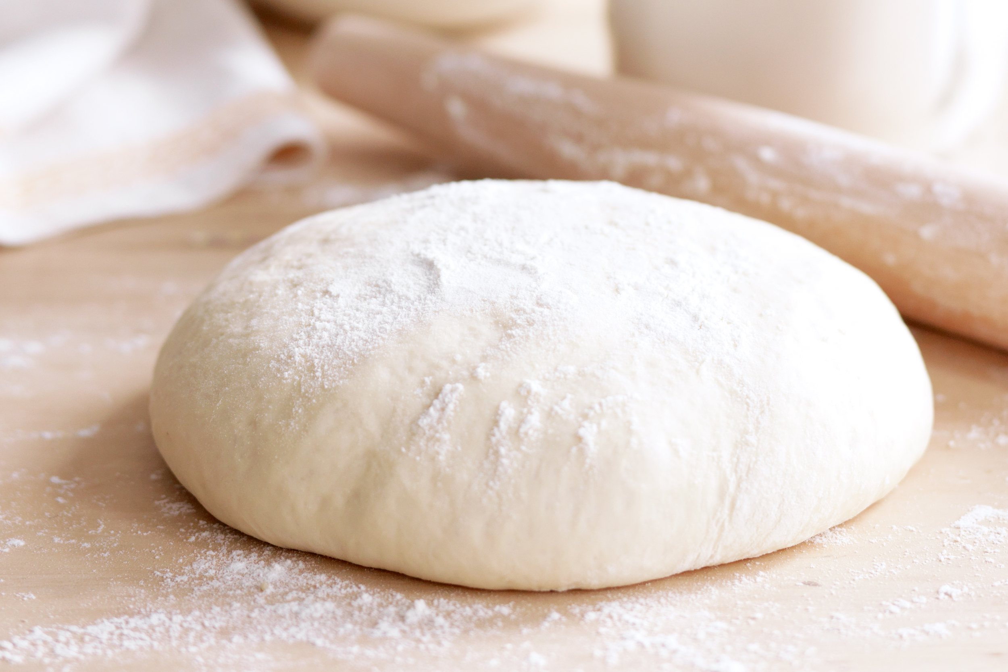1)make the pizza dough

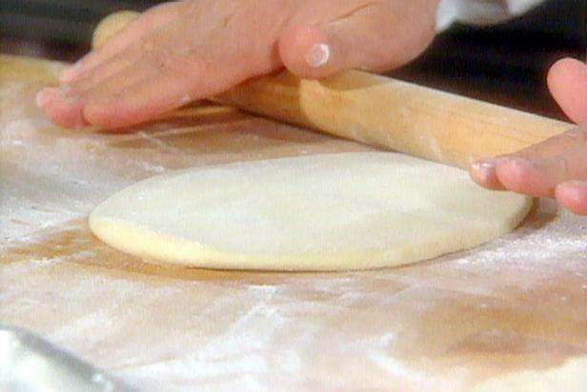2)flatten the dough out to about 0.5 cm thick

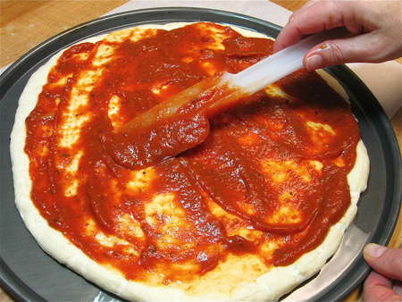3)spread tomato sauce but leave the edges

4)sprinkle cheese and leave the edges

5)cook in an oven for about 15 minutes

6)serve or eat the pizza